Assignment 5

Name: Mohammad Faisal Sayed

1. Create Deadlock between threads

#include <iostream>

#include <thread>

#include <mutex>

std::mutex mutex1, mutex2, mutex3;

void thread1()

{

std::unique_lock<std::mutex> lock1(mutex1);

std::cout << "Thread 1 acquired lock1" << std::endl;

std::this_thread::sleep_for(std::chrono::milliseconds(100));

std::unique_lock<std::mutex> lock2(mutex2);

std::cout << "Thread 1 acquired lock2" << std::endl;

}

void thread2()

{

std::unique_lock<std::mutex> lock2(mutex2);

std::cout << "Thread 2 acquired lock2" << std::endl;

std::this_thread::sleep_for(std::chrono::milliseconds(100));

std::unique_lock<std::mutex> lock3(mutex3);

std::cout << "Thread 2 acquired lock3" << std::endl;

}

void thread3()

{

std::unique_lock<std::mutex> lock3(mutex3);

std::cout << "Thread 3 acquired lock3" << std::endl;

std::this_thread::sleep_for(std::chrono::milliseconds(100));

std::unique_lock<std::mutex> lock1(mutex1);

std::cout << "Thread 3 acquired lock1" << std::endl;

}

int main()

{

std::thread t1(thread1);

std::thread t2(thread2);

std::thread t3(thread3);

t1.join();

t2.join();

t3.join();

return 0;

}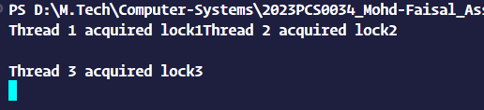

1. Write a program to create four threads: thread1, thread2, thread3, and thread4. Create a deadlock situation between thread1 and thread3.

#include <iostream>

#include <thread>

#include <mutex>

std::mutex mutex1, mutex3;

void thread1()

{

std::unique_lock<std::mutex> lock1(mutex1);

std::cout << "Thread 1 acquired lock1\n";

std::cout << "Now trying to acquire lock on mutex 3....\n";

std::this_thread::sleep_for(std::chrono::milliseconds(100));

std::unique_lock<std::mutex> lock3(mutex3);

std::cout << "Thread 1 acquired lock3\n";

}

void thread2()

{

std::this_thread::sleep_for(std::chrono::milliseconds(50));

std::unique_lock<std::mutex> lock1(mutex1);

std::cout << "Thread 2 acquired lock1\n";

}

void thread3()

{

std::unique_lock<std::mutex> lock3(mutex3);

std::cout << "Thread 3 acquired lock3\n\n";

std::cout << "Now trying to acquire lock on mutex 1....\n";

std::this_thread::sleep_for(std::chrono::milliseconds(100));

std::unique_lock<std::mutex> lock1(mutex1);

std::cout << "Thread 3 acquired lock1\n";

}

void thread4()

{

std::this_thread::sleep_for(std::chrono::milliseconds(50));

std::unique_lock<std::mutex> lock3(mutex3);

std::cout << "Thread 4 acquired lock3\n";

}

int main()

{

std::thread t1(thread1);

std::thread t2(thread2);

std::thread t3(thread3);

std::thread t4(thread4);

t1.join();

t2.join();

t3.join();

t4.join();

return 0;

}

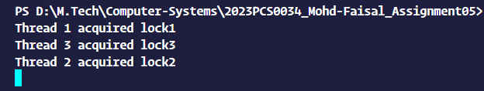

1. Revise the program to avoid deadlock

#include <iostream>

#include <thread>

#include <mutex>

std::mutex mutex1, mutex3;

void thread1()

{

std::unique_lock<std::mutex> lock1(mutex1);

std::cout << "Thread 1 acquired lock1" << std::endl;

std::this_thread::sleep_for(std::chrono::milliseconds(100));

std::unique_lock<std::mutex> lock3(mutex3);

std::cout << "Thread 1 acquired lock3" << std::endl;

}

void thread2()

{

std::this_thread::sleep_for(std::chrono::milliseconds(50)); // Simulate some work

std::unique_lock<std::mutex> lock1(mutex1);

std::cout << "Thread 2 acquired lock1" << std::endl;

}

void thread3()

{

std::unique_lock<std::mutex> lock1(mutex1);

std::cout << "Thread 3 acquired lock1" << std::endl;

std::this_thread::sleep_for(std::chrono::milliseconds(100));

std::unique_lock<std::mutex> lock3(mutex3);

std::cout << "Thread 3 acquired lock3" << std::endl;

}

void thread4()

{

std::this_thread::sleep_for(std::chrono::milliseconds(50)); // Simulate some work

std::unique_lock<std::mutex> lock3(mutex3);

std::cout << "Thread 4 acquired lock3" << std::endl;

}

int main()

{

std::thread t1(thread1);

std::thread t2(thread2);

std::thread t3(thread3);

std::thread t4(thread4);

t1.join();

t2.join();

t3.join();

t4.join();

return 0;

}

/*

both thread1 and thread3 lock mutex1 before attempting to lock mutex3, ensuring that they lock the mutexes in the same order and avoiding a potential deadlock. thread2 and thread4 still simulate some work to delay the acquisition of locks, but now the program will not enter a deadlock state.

*/

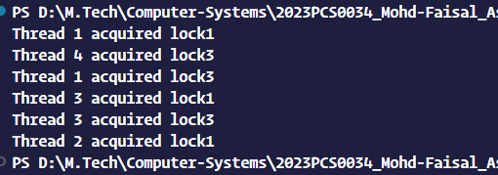

1. Bankers algorithm

#include <iostream>

#include <algorithm>

using namespace std;

int main() {

int n;

cout << "Enter number of processes: ";

cin >> n;

int* finish = new int[n];

int** maxi = new int*[n];

int** alloc = new int*[n];

int** need = new int*[n];

int work[3] = {3, 2, 2};

for (int i = 0; i < n; i++) {

maxi[i] = new int[3];

cout << "Enter 1st resource required for process " << i << ": ";

cin >> maxi[i][0];

cout << "Enter 2nd resource required for process " << i << ": ";

cin >> maxi[i][1];

cout << "Enter 3rd resource required for process " << i << ": ";

cin >> maxi[i][2];

}

for (int i = 0; i < n; i++) {

alloc[i] = new int[3];

cout << "Enter 1st resource allocated for process " << i << ": ";

cin >> alloc[i][0];

cout << "Enter 2nd resource allocated for process " << i << ": ";

cin >> alloc[i][1];

cout << "Enter 3rd resource allocated for process " << i << ": ";

cin >> alloc[i][2];

}

for (int i = 0; i < n; i++) {

need[i] = new int[3];

for (int j = 0; j < 3; j++) {

need[i][j] = maxi[i][j] - alloc[i][j];

}

}

int i = 0;

int j = 0;

while (j < 3 * n && (std::find(finish, finish + n, 0) != finish + n)) {

int flag = 0;

j++;

if (need[i][0] <= work[0] && need[i][1] <= work[1] && need[i][2] <= work[2]) {

work[0] += alloc[i][0];

work[1] += alloc[i][1];

work[2] += alloc[i][2];

finish[i] = 1;

flag = 1;

i = (i + 1) % n;

}

if (flag == 0) {

i = (i + 1) % n;

}

}

int nflag = 0;

for (int i = 0; i < n; i++) {

if (finish[i] == 0) {

nflag = 1;

break;

}

}

if (nflag == 0) {

cout << "System is in safe state" << endl;

} else {

cout << "System is in deadlock" << endl;

}

// Free allocated memory

delete[] finish;

for (int i = 0; i < n; i++) {

delete[] maxi[i];

delete[] alloc[i];

delete[] need[i];

}

delete[] maxi;

delete[] alloc;

delete[] need;

return 0;

}

